**USECASE 5  
Create an Azure Storage Account SOP**

**1. Storage Account creation from Azure Portal:**

**Click on Add Storage account:**

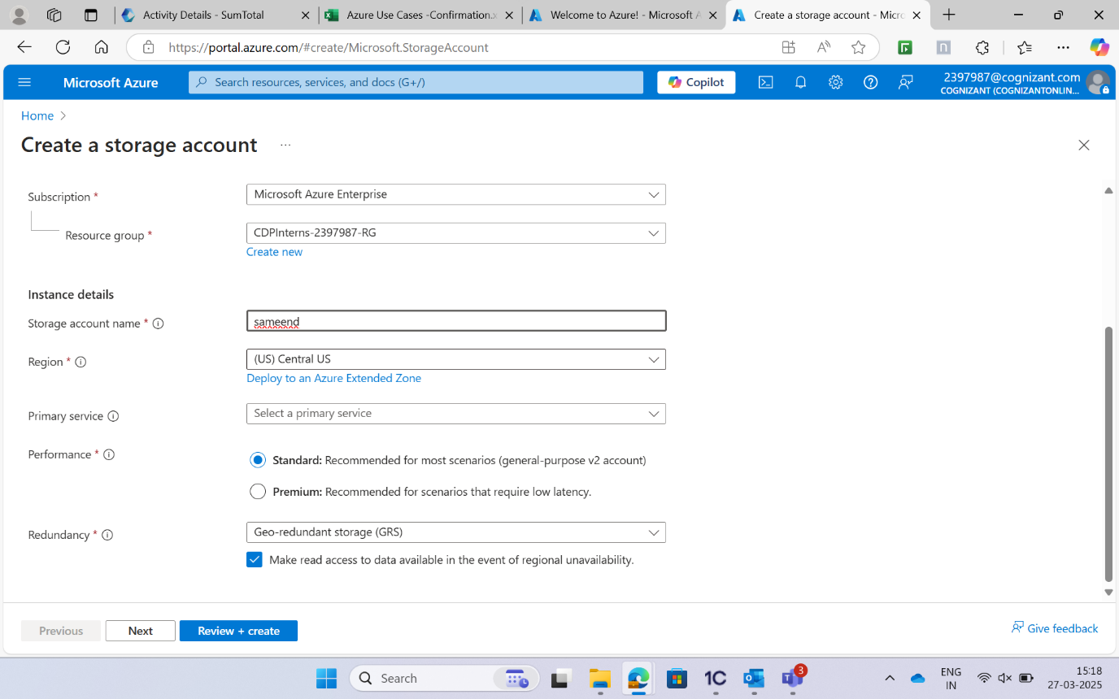

**In the Advanced Tab, set Hierarchical Namespace to Enabled:**

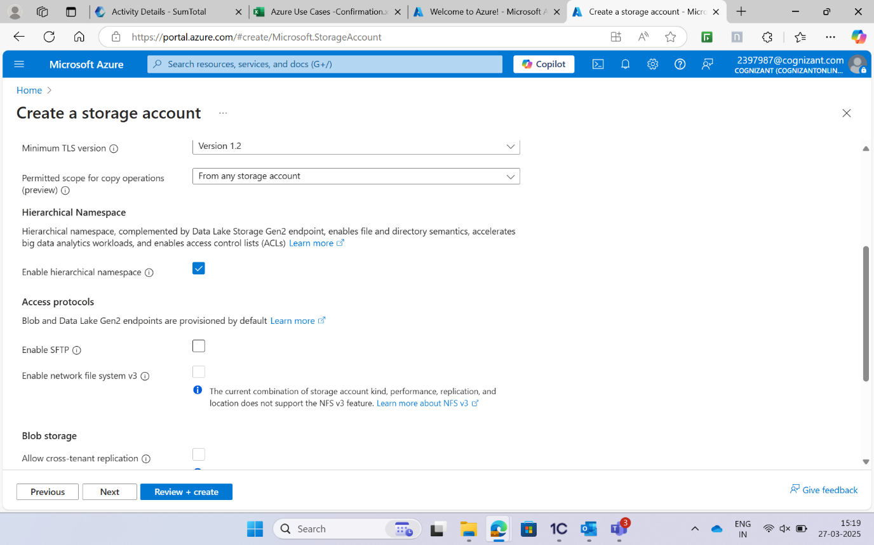

**Click on Review + Create > Create:**

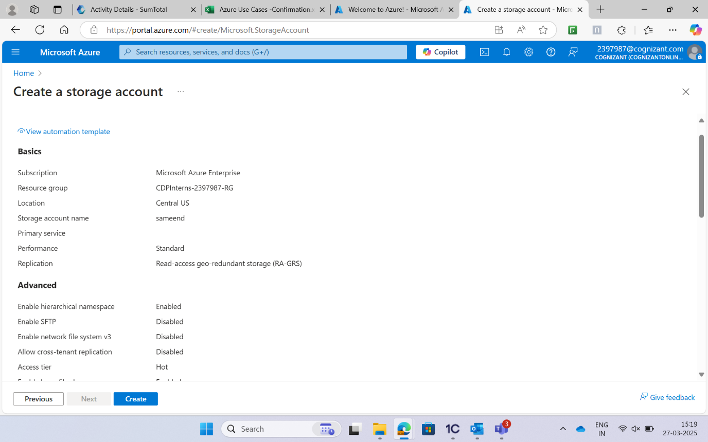

**2. Storage Account Creation by PowerShell:**

**Launch the PowerShell from your local or from Azure Cloud Shell:**

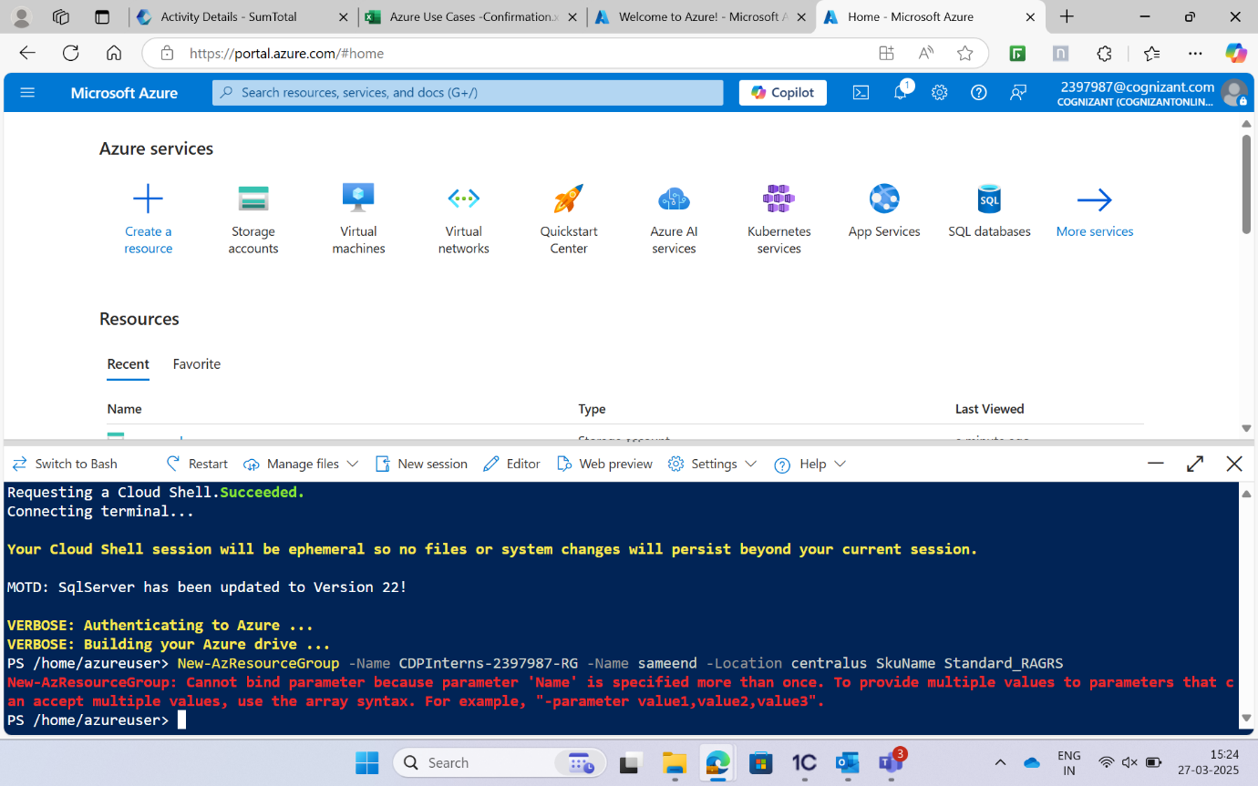

**Sample command to create a storage account:**

